1.
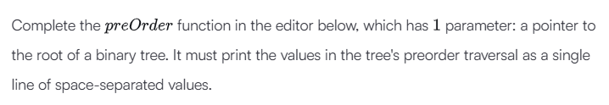
Ans.
class Node:
def __init__(self, info):
self.info = info
self.left = None
self.right = None
self.level = None
def __str__(self):
return str(self.info)
class BinarySearchTree:
def __init__(self):
self.root = None
def create(self, val):
if self.root == None:
self.root = Node(val)
else:
current = self.root
while True:
if val < current.info:
if current.left:
current = current.left
else:
current.left = Node(val)
break
elif val > current.info:
if current.right:
current = current.right
else:
current.right = Node(val)
break
else:
break
def preOrder(root):
if root:
print(root.info, end=" ")
preOrder(root.left)
preOrder(root.right)
tree = BinarySearchTree()
t = int(input())
arr = list(map(int, input().split()))
for i in range(t):
tree.create(arr[i])
preOrder(tree.root)

2.
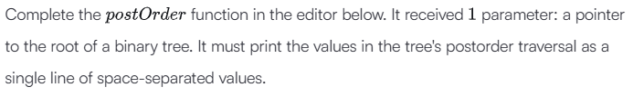
Ans.
class Node:
def __init__(self, info):
self.info = info
self.left = None
self.right = None
self.level = None
def __str__(self):
return str(self.info)
class BinarySearchTree:
def __init__(self):
self.root = None
def create(self, val):
if self.root == None:
self.root = Node(val)
else:
current = self.root

while True:
if val < current.info:
if current.left:
current = current.left
else:
current.left = Node(val)
break
elif val > current.info:
if current.right:
current = current.right
else:
current.right = Node(val)
break
else:
break
def postOrder(root):
if root:
postOrder(root.left)
postOrder(root.right)
print(root.info, end=" ")
tree = BinarySearchTree()
t = int(input())
arr = list(map(int, input().split()))
for i in range(t):
tree.create(arr[i])
postOrder(tree.root)
3.
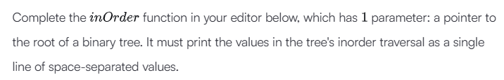
Ans.
class Node:
def __init__(self, info):
self.info = info
self.left = None
self.right = None
self.level = None
def __str__(self):
return str(self.info)
class BinarySearchTree:
def __init__(self):
self.root = None
def create(self, val):
if self.root == None:
self.root = Node(val)
else:
current = self.root

while True:
if val < current.info:
if current.left:
current = current.left
else:
current.left = Node(val)
break
elif val > current.info:
if current.right:
current = current.right
else:
current.right = Node(val)
break
else:
break
def inOrder(root):
if root:
inOrder(root.left)
print(root.info, end=" ")
inOrder(root.right)
tree = BinarySearchTree()
t = int(input())

arr = list(map(int, input().split()))
for i in range(t):
tree.create(arr[i])
inOrder(tree.root)
4.
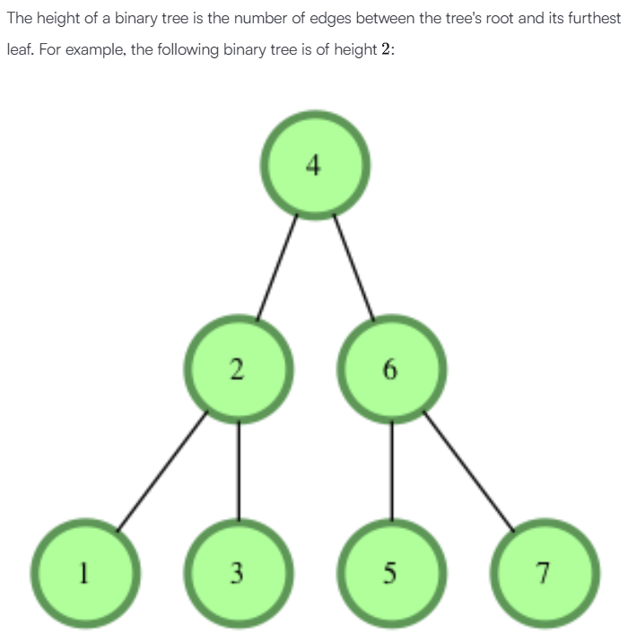
Ans.
class Node:
def __init__(self, info):
self.info = info
self.left = None
self.right = None
self.level = None

def __str__(self):
return str(self.info)

class BinarySearchTree:
def __init__(self):
self.root = None

def create(self, val):
if self.root == None:
self.root = Node(val)
else:
current = self.root

while True:
if val < current.info:
if current.left:
current = current.left
else:
current.left = Node(val)
break
elif val > current.info:
if current.right:
current = current.right
else:
current.right = Node(val)
break
else:
break
def height(root):
if root is None:
return -1
return 1 + max(height(root.left), height(root.right))

tree = BinarySearchTree()
t = int(input())

arr = list(map(int, input().split()))

for i in range(t):
tree.create(arr[i])

print(height(tree.root))
5.
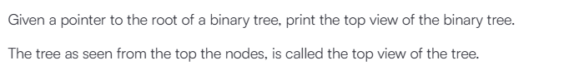
Ans.
class Node:
def __init__(self, info):
self.info = info
self.left = None
self.right = None
self.level = None

def __str__(self):
return str(self.info)

class BinarySearchTree:
def __init__(self):
self.root = None

def create(self, val):
if self.root == None:
self.root = Node(val)
else:
current = self.root

while True:
if val < current.info:
if current.left:
current = current.left
else:
current.left = Node(val)
break
elif val > current.info:
if current.right:
current = current.right
else:
current.right = Node(val)
break
else:
break
def topView(root):
if not root:
return

queue = [(root, 0)]
hd_map = {}

while queue:
node, hd = queue.pop(0)

if hd not in hd_map:
hd_map[hd] = node.info

if node.left:
queue.append((node.left, hd - 1))
if node.right:
queue.append((node.right, hd + 1))

for hd in sorted(hd_map.keys()):
print(hd_map[hd], end=" ")

tree = BinarySearchTree()
t = int(input())

arr = list(map(int, input().split()))

for i in range(t):
tree.create(arr[i])

topView(tree.root)
6.
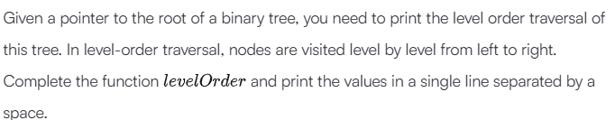
Ans.
class Node:
def __init__(self, info):
self.info = info
self.left = None
self.right = None
self.level = None

def __str__(self):
return str(self.info)
class BinarySearchTree:
def __init__(self):
self.root = None
def create(self, val):
if self.root == None:
self.root = Node(val)
else:
current = self.root
while True:
if val < current.info:
if current.left:
current = current.left
else:
current.left = Node(val)
break
elif val > current.info:
if current.right:
current = current.right
else:
current.right = Node(val)
break
else:
break
def levelOrder(root):
if not root:
return
queue = [root]
while queue:
node = queue.pop(0)
print(node.info, end=" ")
if node.left:
queue.append(node.left)
if node.right:
queue.append(node.right)
tree = BinarySearchTree()
t = int(input())
arr = list(map(int, input().split()))
for i in range(t):
tree.create(arr[i])
levelOrder(tree.root)

7.
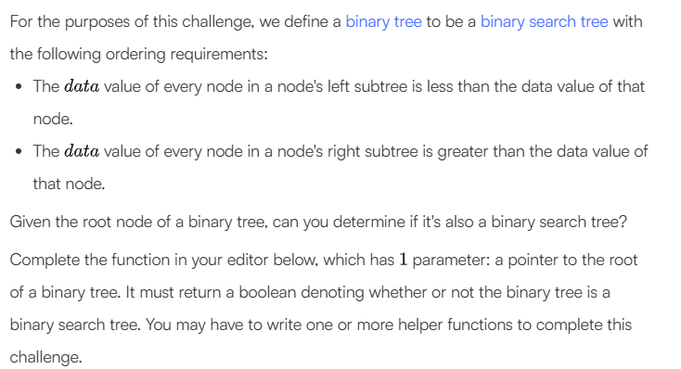
Ans.
class node:
def __init__(self, data):
self.data = data
self.left = None
self.right = None

def newNode():
temp = node(-1)
temp.left = None
temp.right = None
return(temp);
def check_binary_search_tree_(root):
def validate(node, min_val, max_val):
if node is None:
return True

if not (min_val < node.data < max_val):
return False

return validate(node.left, min_val, node.data) and validate(node.right, node.data, max_val)

return validate(root, float('-inf'), float('inf'))

ht = int(input())
cnt = 0
values = map(int, input().split(' '))
values = list(values)
root = newNode()
def inorder(root, ht):
global cnt
global values
if cnt == len(values):
return
else:
if(ht>0):
root.left = newNode();
inorder(root.left, ht-1);
root.data = values[cnt];
cnt+=1
if(ht>0):
root.right = newNode();
inorder(root.right, ht-1);
inorder(root, ht);
if(check_binary_search_tree_(root)):
print("Yes")
else:
print("No")

